# Hospice

The current structure is as follows:

The package that is in production is the “ETLPackage.dtsx”. This uses the ETLCore and configuration settings. The FolderLoopingPackage is a temporary one to get files loaded in a quick fashion in Q3 2018. The Production version is located here: G:\artifacts\prod\com.pharmmd.etl.Hospice.

The importance of the Hospice data is that it means we cannot do outreach on these members. Typically, we get a client identifier that we have to match up to a PMDPatientID to place these members into the CallListPatientsControl table on SQLOPS.

The package is currently set up to load .csv or .xls/.xlsx files but we prefer a simple standard.

This sub ETL process follows the Session->Raw->Spec process of loading and progressing data from file to the database.

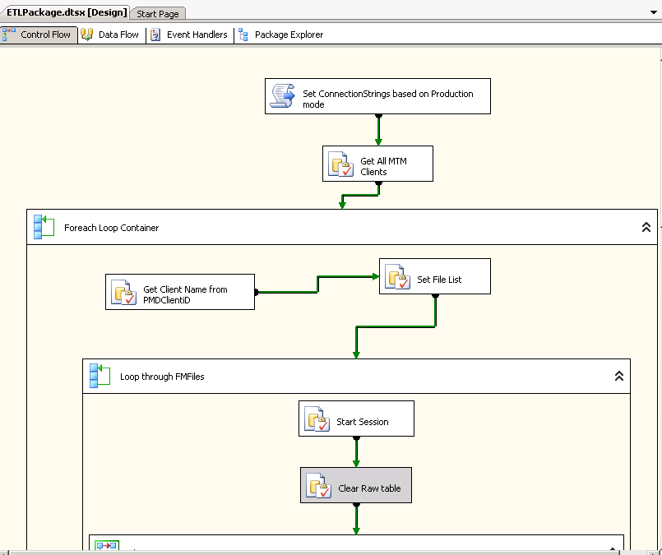

**Figure 1.** Looping Package – Retrieve all clients marked as “Hospice” from the ETLAutomation.dbo.ClientParameters table